**Exercise 3 – MTA coin on containers**

**Objective**

Practice IPC(inter-process communication), container-based development, packaging and shipment.

**Overview**

Modify the application from exercise 2 so that the server and each of the miners will run on a separate container and communicate with each other via **named pipe**.

**Detailed description**

Create 2 docker images:

1. Miner - Shall contain the miner application process and create a **named pipe** in a predefined mounted path (e.g. /mnt/mta/server_pipe, “/mnt/mta” path can be defined at build time and hard coded in the code). Upon init the miner shall perform the following:
   1. Open a pipe whose name shall contain the miner id, (take the following vacant number (e.g. “miner_pipe_3” if “miner_pipe_1” & “miner_pipe_2” are already in use).
   2. The miner shall send a subscription request(message) with the queue name to the server’s pipe, the server shall answer with the current block data.
   3. Wait on the pipe to receive the first block.
   4. Start mining, **remember** to check if there is a new block on each iteration (hint: use O_NONBLOCK option).
   5. Upon successful mining send the new block to the server and keep mining.
2. Server – Shall contain the server application and handle 2 types of messages:
   1. New miner subscription – receive the miner id and send current block to its pipe.
   2. New block received – validate block, if approved, broadcast the new block to all miners.

**Note:** Assume server container will always run before miners, no need to handle specific miner container termination.

**Note 2:** Each container application should write its logs into a dedicated file under /var/log (optionally you can use syslog).

**Note 3:** Server shall read the difficulty from a configuration file instead of user argument, the conf file should placed by the user in the mounted directory before the server container is started:



**Example screenshots**

Images:

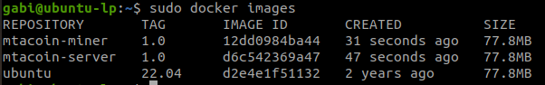

Containers execution (servers + server logs + miners):

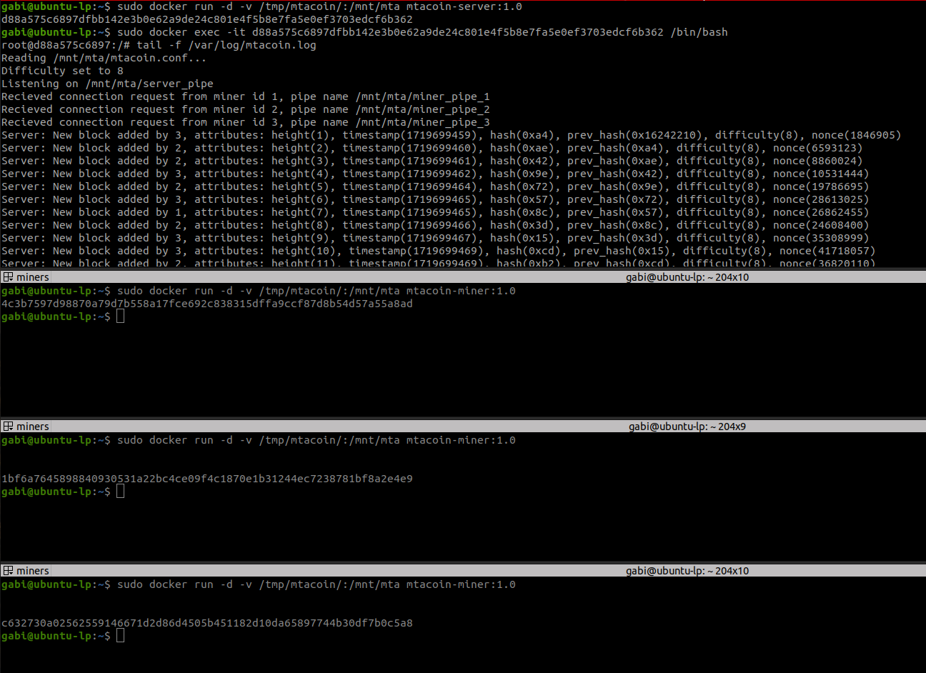

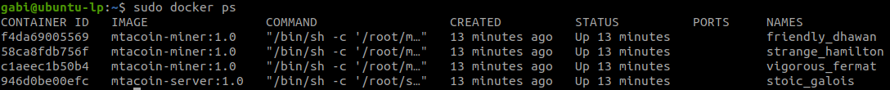

Miner execution + logs:

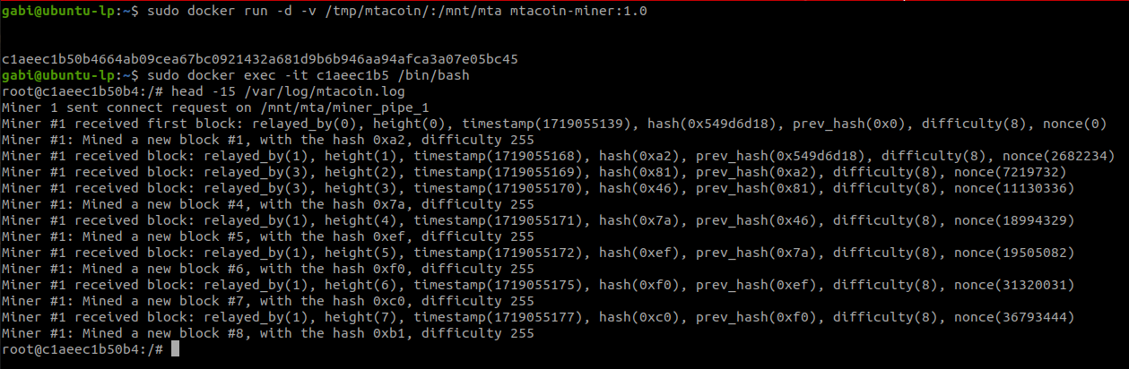

Pipes and conf dir:

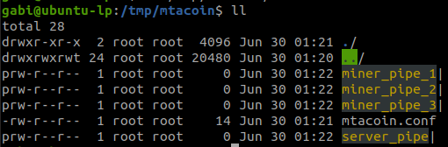

**Submission**

Submit 2 images using docker hub, tutorial: <https://docs.docker.com/docker-hub/>

Submit to MAMA a **zip file** with:

1. Source code (c/cpp code, makefile/cmake, Dockerfiles)
2. Readme with your IDs and instructions how to run the containers and preferably a script that launches the whole system (e.g. launcher.sh)